DEPARTMENT OF SOCIAL WORK
Swachhata Pakhwada Abhiyan(16th-31st January 2020)
Workshop on Solid Waste Management

Date :-24thJanuary 2020 Day- Friday
Topic: “ Best Out Of Waste” (Solid Waste Management And Sustainability)
The workshop was organized at Seminar Hall,DharamsalaParisar1,Central University of Himachal Pradesh at 10:00Am by Dept.of Social Work in collaboration with Waste warriors,a Dharmamsala based NGO. Resource person: Etosha Chatterjee,Manager(Waste Warrior) Waste Warriors,a waste management based NGO working in Dharamsala since 2012, functioning under 3 protocols –a).Direct actions and operations b). Outreach and partnerships c).Education.The Department also conducts regualar camps all over Dharmsala. The workshop was attended by faculty members and students of different Departments.
Total participants: 62
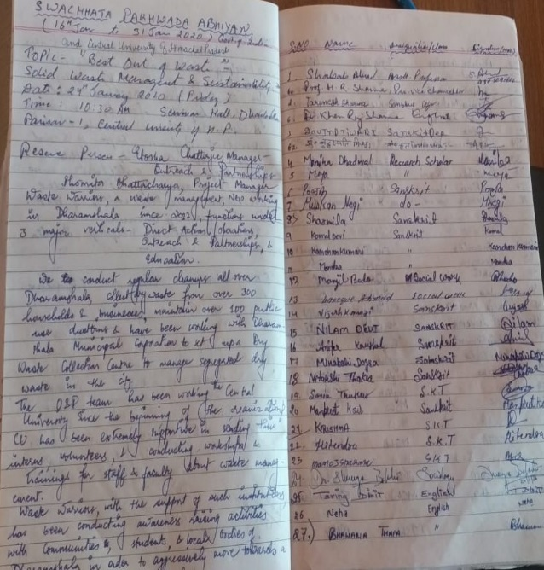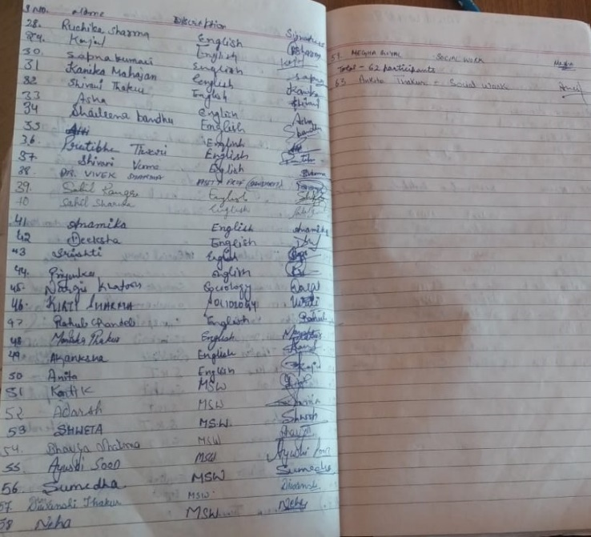
Dated- 24th January 2020

Record of National Immunization Day (NID) Jan 2020
Deployment of MSW students of the Department of Social Work, CUHP in various districts/pockets of Himachal Pradesh as External Monitors
S.No | Monitor Name | District Allotted | Block to be monitored
1 | Megha | Bilaspur | Ghumarwin, BilaspurSadar
2 | ZubairAlam | Chamba | Bhattiyat, Mehla
3 | Ayushi | Hamirpur | Toni Devi, Badsar
4 | Neha | Hamirpur | Sujanpur, Nadaun
5 | Shiwani | Kangra | Nurpur , Indora
6 | Sargam | Kangra | Bhawarna, Nagrotabagwan
7 | Meena | Kangra | Rait, Kangra
8 | Shruti | Kullu | Naggar, Jari
9 | Adarsh | Mandi | Sunder Nagar, Mandi Sadar
10 | Ankita | Shimla | Mashobra, Shimla Urban
11 | Minhaz Khan | Sirmour | Dhagera, Paonta
12 | Shahrukh Khan | Solan | Dharampur
13 | ManzilBodo | Una | Haroli, Gagret

IN NEWS
