 | Central University of Himachal Pradesh  School Of Journalism, Mass Communication & New Media | 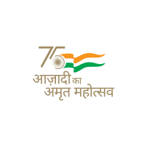
Media Film Club
Innovative training
Learning through Cinema

Cinema is the important part of our society. Through cinema one get entertain and educate at the same time. In simple words we can say that cinema has become the most common media of edutainment.
Media Film Club is such an initiative of School of Journalism, Mass Communication & New Media to develop a better understanding of Cinema among the students.
With the activities of the Media Film club, School of Journalism, Mass Communication & New Media has screened as many movies as possible so that students can build a better domain of the Film understanding.

Table 1: List of Films Screened by Media Film Club
Sr. No. | Movie Screened | Date of Screening
1. | Chhoti Si Baat (1976) | 20th May, 2022
2. | Modern Times (1936) | 3rd June, 2022
3. | Bicycle Thieves (1948) | 20th September, 2022
4. | Sully: Miracle on Hudson (2016) | 18th November, 2022
5. | The Gods Must Be Crazy (1980) | 25th November, 2022
6. | Exam (2009) | 10th February, 2023
7. | Dead Poets Society (1989) | 17th February, 2023
